PROJECT REPORT
DIGITAL LITERACY
(CSEOOO1)
E21

By
Yukta Lilhare
(25BMR10024)

Kannan.S
Faculty

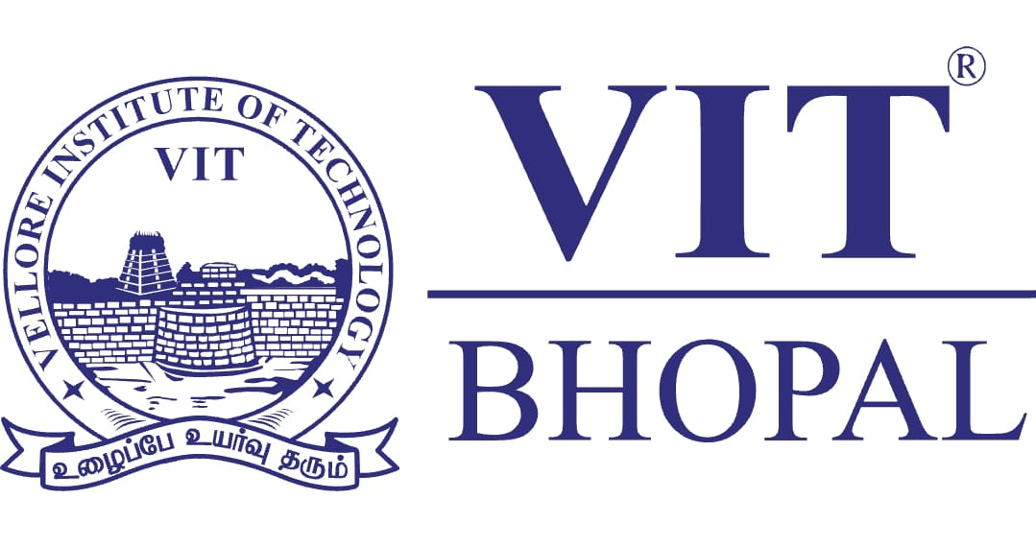

VIT Bhopal University
Kothrikalan-466114
Madhya Pradesh,
INDIA.
Introduction

Project Overview and Scenario
This project focuses on developing essential digital literacy skills required for students in an increasingly digital world. As part of the assignment, the role assumed is that of a Student Digital Ambassador, responsible for guiding peers in using digital tools effectively, maintaining a professional online presence, and ensuring safe and responsible online behaviour.
The scenario emphasizes real-world applications such as creating online portfolios, practicing professional communication, collaborating through digital platforms, and understanding cyber threats. The project is divided into multiple tasks that cover areas like infographic creation, platform exploration, email etiquette, and cybercrime awareness. Each task contributes to building a comprehensive digital literacy portfolio.
Overall, the project aims to enhance practical knowledge, encourage responsible digital habits, and prepare students for academic and professional environments where digital competence is essential.

TASK- 1 : PRESENTATION
I used Canva to create my presentation on digital literacy. The app provided a simple and user-friendly interface with various templates, icons, and design elements, which made it easy to organize my content visually. I selected a clean layout and used different coloured sections to present key topics such as it’s definition, useful digital tools, safe internet practices, professional online presence, and email etiquette.
My design shows a structured overview of these concepts in a visually appealing format. Each section includes short points and relevant icons to make the information easy to understand and engaging.
One thing I found interesting while making this design was how blending different colours, fonts to make information more visually attractive. However, I found it slightly difficult to maintain proper spacing and alignment so that the design looked neat and balanced. Overall, it was a creative and informative experience.
TASK - 2 : PORTFOLIO
They are essential platforms for students building a professional digital presence. GitHub is mainly used for storing, managing, and sharing code. It allows users to work on projects, collaborate with others, and showcase technical skills through repositories. LinkedIn, on the other hand, is used for professional networking, where individuals can create profiles, connect with professionals, and explore job or internship opportunities.
Over the next four years, I plan to actively use GitHub to upload my academic projects, practice coding, and contribute to open-source projects to improve my technical skills. It will also serve as a portfolio to demonstrate my work to recruiters. On LinkedIn, I aim to build a strong profile by adding my achievements, certifications, and experiences. I will connect with industry professionals, follow companies, and stay updated with trends in my field. By consistently using both platforms, I intend to enhance my skills, expand my network, and improve my career opportunities.

TASK - 3 : PLATFORMS
I used Google Forms and Hacker Rank as the primary platforms to complete this task. On Google Forms, I created a Digital Literacy Awareness Quiz consisting of five well-structured questions, including multiple choice and short answer types. This helped me understand how to design surveys, structure questions clearly, and use features like answer keys and response settings. On Hacker Rank, I practise the “Solve Me First” problem, where I implemented a simple function to add two integers. This strengthened my understanding of basic programming concepts such as input handling, functions, and output formatting.
These tools are highly beneficial for my academic growth. Google Forms will help me in conducting surveys, collecting data for projects, and presenting information in an organized manner. Hacker Rank, on the other hand, will improve my coding skills, logical thinking, and problem-solving ability, which are essential for technical subjects and placements. Overall, using these platforms enhances both my digital literacy and practical knowledge, making me more efficient and confident in academic tasks.

TASK - 4 : DIGITAL COMMUNICATION
Poor digital communication can lead to serious misunderstandings. For example, a student once sent a short and informal email to a professor saying, “I can’t submit this now, extend it.” The message lacked a proper greeting, explanation, and respectful tone. The professor perceived it as rude and unprofessional and refused the request for an extension. This created unnecessary conflict and stress for the student.
The situation could have been handled differently by using proper email etiquette. A polite greeting, a clear explanation of the situation, and a respectful request would have made a positive impression. Professional communication not only conveys the message effectively but also reflects the sender’s attitude and responsibility. This example highlights how tone, structure, and clarity play a crucial role in digital interactions.

TASK - 5 : CYBERCRIME AWARENESS
While researching UPI fraud, what surprised me most was how simple and psychological these scams are. Fraudsters do not rely on complex hacking but instead exploit trust, urgency, and lack of awareness. Even educated users, especially students, can fall victim within seconds by unknowingly authorizing payments themselves. The fact that a single click or PIN entry can lead to immediate financial loss was particularly alarming.
As a result, one habit I will personally change is being more cautious before taking any action related to payments. I will make it a rule to verify every request, link, or call before responding, no matter how genuine it appears. Developing this habit will help me stay alert and protect myself from such frauds in the future.

Conclusion
This Digital Literacy project provided a comprehensive understanding of the skills required to function effectively in today’s digital environment. Through the completion of all tasks, it became clear that digital literacy extends beyond basic technical knowledge and includes responsible behavior, critical thinking, and professional communication. Creating an infographic helped in understanding how to present information clearly and creatively, while building a digital portfolio highlighted the importance of maintaining a professional online presence.
Exploring coding platforms and collaborative tools demonstrated how technology can support academic growth and teamwork. The email etiquette task emphasized the value of structured and respectful communication, which is essential in both academic and professional settings. Additionally, the cybercrime case study and prevention checklist increased awareness about online threats and the importance of practicing safe digital habits.
Overall, this project strengthened practical skills and encouraged a more mindful approach to using digital platforms. It has prepared me to navigate the digital world more confidently and responsibly, while also enabling me to guide others as a Digital Ambassador. The knowledge gained will be valuable not only during my academic journey but also in future professional environments.
References
VIT Bhopal University. CSE0001 – Digital Literacy Project Brief (course material).
National Cyber Crime Portal – https://www.cybercrime.gov.in
Reserve Bank of India – Guidelines on safe digital payments and fraud awareness
Google – Google Forms and Workspace tools (forms.google.com)
Canva – Infographic creation tool (canva.com)
LinkedIn – Professional profile development
GitHub – Portfolio and repository hosting
HackerRank – Coding practice and skill development

